Project Design Phase-II

Data Flow Diagrams &user stories

Data Flow Diagram:

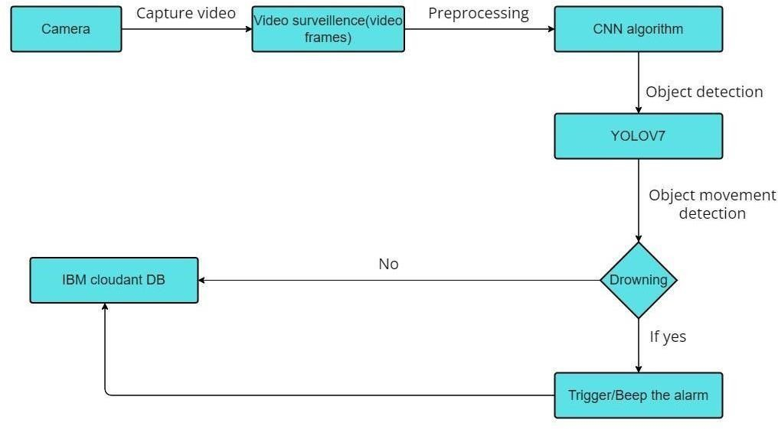

**User Stories**

Use the below template to list all the user stories for the product.

|  |  |  |  |  |  |  |
| --- | --- | --- | --- | --- | --- | --- |
| **User Type** | **Functional Requirement**  **(Epic)** | **User Story**  **Number** | **User Story / Task** | **Acceptance criteria** | **Priority** | **Release** |
| Customer (Supervisor) | Installation | USN-1 | They set the camera and install and  configure the system in swimming pools | The software is  installed and cameras are setup | High | Sprint-1 |
|  | Pre-processing | USN-2 | Train and test the model | Train the model by using datasets | High | Sprint-1 |
|  | Detection of drowning | USN-3 | The swimmers can be monitored by cameras | Camera surveillance | High | Sprint -2 |
|  |  | USN-4 | Swimmers canbedetected through their actions | Detection of drowning | High | Sprint-2 |
|  | Alarm rings | USN -5 | Alarm rings When the system detects drowning person | Alert the lifeguard | High | Sprint-3 |
| Lifeguard | Saves the person | USN-6 | The Lifeguard saves the swimmer who is drowning once the alarm rings | Saves the life of people | High | Sprint-3 |

|  |  |  |  |  |  |  |
| --- | --- | --- | --- | --- | --- | --- |
| Administrator | Register | USN-7 | Register into the application | Admin can access the account | Medium | Sprint-2 |
|  | Login | USN-8 | Login and manage the application | Manage system | Medium | Sprint-2 |
|  |  | USN-9 | Stores the database | Storage the database | Medium | Sprint-2 |